Module 3: Selenium WebDriver
Total sessions: 24
Name of Trainer: Ankush Vankore

- Selenium WebDriver (12-13 Sessions)
  - Automation Basics
  - Introduction to Selenium
  - Configuration of WebDriver
  - Launching Different browsers
    - Chrome
    - Edge
    - Firefox
  - Basic Methods
    - get()
    - getTitle()
    - getCurrentUrl()
    - getPageSource()
  - Locators
    - Id
    - Name
    - CssSelector
    - ClassName
    - XPath
    - LinkText
    - PartialLinkText
    - TagName
  - Handling Controls
    - Text Box
    - Command Button
    - Radio Button
    - Hyperlinks
    - Checkbox
    - Images
    - Dropdown Lists
    - List Box
  - Synchronization
    - Thread.sleep()
    - ImplicitWait
    - ExplicitWait
    - FluentWait
    - PageLoadTimeout
  - Handling Tables (Web Tables)
    - Static Table
    - Dynamic Table
    - Pagination Table
  - Multiple window handling
  - Headless Browser
  - File Upload
  - Robot Class
  - Calendar Automation
  - Navigation Methods
    - Back
    - Forward
    - Refresh
  - JavascriptExecutor
    - Scrolling the page
    - Clicking on controls
  - Alert Handling
    - Simple Alert
    - Confirmation Alert
    - Prompt Alert
  - Mouse Actions
    - Hover
    - Right Click
    - Double Click
    - Drag and Drop
  - Keyboard Actions
  - Iframe / Frame Handling
  - Shadow Root elements
  - Screenshot
- TestNG
  - Introduction
  - Installation
  - Configuration
  - Annotations
    - @Test
    - @BeforeTest
    - @AfterTest
    - @BeforeMethod
    - @AfterMethod
    - @DataProvider
    - @Parameter
    - @BeforeClass
    - @AfterClass
  - Executing single test / multiple tests
  - Parameterization
  - Setting the priority to the tests
  - Data driven testing
  - Execution via XML file
  - Assertions
  - Parallel Testing (Execution)
  - Keyword Driven Framework
  - Page Object Model (POM)
  - Data driven framework (Read / Write data to Excel file) – Apache POI
  - Listeners
- Introduction to Maven
  - Introduction to Maven
  - Create a Maven Project
  - Dependencies
  - Maven Execution
  - Extent Report
- Cucumber
  - Introduction
  - BDD Framework
  - Components of BDD
    - Feature File (Gherkin Language)
    - Step Definition
    - Runner Class
  - Tags in Cucumber
  - Hooks in Cucumber
  - Data Driven Testing in Cucumber

What is Software Testing?
Is a process of checking the Correctness, Completeness, Security & Quality of developed software application.

Process
- Requirements (SRS)
- Create Test Scenarios
- Create Test Cases
- Create Test Data
- Creating RTM
- Execute the test cases
- Report

Steps
- Enter data in text box
- Navigation from one page to another using links
- Clicking the button
- Select option/s from multiple options (Like dropdown list, list box, checkbox, radio button)
- Upload files
- Calendars handling
- Scroll
- Verify the expected result with actual result
- Mark the test case as pass or fail

Automation testing is nothing but performing all above actions with help of a machine.
Machine in this context is a Test Automation Tool.
Every tool understands a specific programming language, so you need to provide the instructions in any one of the supported language.
Advantages of Automation
- Avoids repetition
- Regression Testing
- Reduces the time of execution
- Faster execution
- Saves the time
- Saves the cost
- Reusability of the script
- Avoids human mistakes
- Less human power
- Robust code
- 100% test coverage
- Accuracy
When we can automate?
- Stable requirements & application
- Performance testing
- Repeated scenarios
- Quick regression
- Compatibility Testing
- Large amount of data to be tested
Types of Automation Testing
- Unit Testing
  - JUnit
  - NUnit
  - TestNG
- API Testing
  - RestAPI
  - Postman
  - Playwright
- Functional / GUI Testing
  - Selenium
  - Playwright
  - Tosca
Process of Automation
- Planning
- Selection of the tool
  - The type of application that you are testing
  - Cost of tool
  - Testers availability
  - Easy of using the tool (Easy to use, learn)
  - Community support
  - Reporting facility
- Automation script creation (Code)
- Test Data Creation
  - Real Data – data which is provided by client
    - XML file
    - Excel
  - Synthetic Data – data which is created or considered by tester
    - ECP
    - BVA
    - EG
- Execution
- Reporting
- Maintance

Selenium
Selenium is a suite / bundle of test automation tool to test web based applications. (Web Site)
Components of Selenium
- Selenium IDE (Record & Playback)
- Selenium Grid (Parallel Execution)
- Selenium RC (Remote Control)
- Selenium WebDriver

Selenium WebDriver
- It is the open source tool to test web based application
- It is an API
- WebDriver is an interface of Java
- It is very popular tool in automation industry
- Very easy to use & learn
- Supports multiple languages like Java, Python, JavaScript, C#. Net & Ruby
- Selenium WebDriver script can be executed on any browser any platform (OS)

Pre-requisite for Selenium WebDriver
- Minimum Windows 10
- Any one updated browser
- Minimum JDK 11 (Java 11)
  - Fire the command on Command Prompt Java –version
- IDE
  - Eclipse
  - VS Code
  - Idea Intellij
- Selenium WebDriver Jar file
- Let’s create 2 folders with name
  - YourName_SeleniumDemos To store all the demos
  - Selenium-To store all the supported files (Jar Files)

Configuration
- Open selenium.dev site
- Click on Downloads
- Download - Latest stable version 4.51.0
- Open Downloads folder
- Copy the file which is downloaded in step 3
- Paste this file in the 2nd folder which we have created in earlier step (Pre-requisite - Selenium Jar Files)
- Open Eclipse
- Select 1st folder (YourName_SeleniumDemos) as a workspace
- Click on Launch
- In Eclipse close the welcome window
- Create a Project
  - File New Java Project
  - Give the name to project
  - Select any Java version greater than 11
  - Uncheck create module-info.java file checkbox
  - Click on Finish
- Create a package inside the project (Specially in src folder)
- Create a class inside this package
- Selenium WebDriver Configuration
  - Right click on you project (from package explorer)
  - Go to Build Path menu
  - Click on Configure Build Path…
  - Click on Library tab
  - Click on classpath
  - Click on Add External Jars… button
  - Select the 2nd folder (Selenium Jar Files)
  - Select the file which we have downloaded in earlier steps
  - Click on Open button
  - Click on Apply and Close button

Selenium Methods
- Launching the browser Create object of WebDriver interface, it will launch the blank browser window.
- get() Will open the web site by providing the URL. Pass the absolute URL. Absolute URL starts with http
- close() Will close the browser window which is opened by current WebDriver object.
- driver.manage().windows().maximize() Will maximize the browser window.
- getTitle() Will return the title of the web page. (String)
- getCurrentUrl() Will return the URL of the current web page. (String)
- getPageSource() Will return the HTML code of the page (String)
- findElement() Will locate any control / WebElement on the page. It will locate the first occurrence. (WebElement)

WebElement:
- Every control on the web page (like text box, radio button, command button, dropdown list, date time picker, file upload, hyperlinks etc.) is treated as WebElement in Selenium.
- In Selenium we are having WebElement as interface which can hold a single control from the page.
- Methods of WebElement
  - sendKeys() Will enter the text in text box
  - click() Will left click on the control.
  - getText() Will return the text on the control. (String)

Locators:
Locators are the way/s to identify any WebElement (Control) on the page. Technically these are the strategies to locate any control on the page.
There are 8 locators in Selenium
- Name
- Id
- ClassName
- CssSelector
- XPath
- LinkText
- PartialLinkText
- TagName

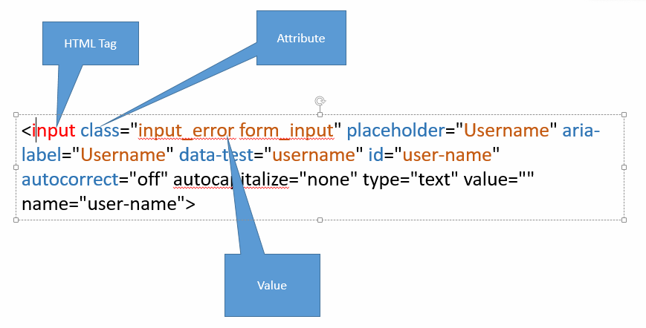
Common Exceptions in WebDriver
- InvalidArgumentException The URL which is passed in .get() is not in the correct format.
- NoSuchSessionException Selenium WebDriver has closed the browser (session) and still you are trying to perform some actions.
- SessionNotCreatedException The version of Selenium and version of browser are mismatching. (Any one is the older version)
- NoSuchElementException Selenium is unable to locate this control due to
  - The locator value may be wrong.
  - The value of attribute may be dynamic.
  - The control is not on the page.
- InvalidSelectorException Typically when you are locating a control via className and your control is having multiple classes any you might using all those classes. Use only one class from such multiple classes.

Locator Class Name:
- You can locate a control using class attribute of control.
- The control may having multiple classed applied. Such multiple classes are separated via space.
- If you are using className locator then use any one class from these multiple classes.

CssSelector Locator:
It is the technique to locate any control using any one or multiple attributes of the control.
Types
- Using single attribute
Syntax:
tagName[attribute=’value’]
- Using multiple attributes
Syntax:
tagName[attribute1=’value’][attribute2=’value’]
- Using special characters
  - ^ - Starts with – if the attribute’s starting characters are fixed and ending characters are changing.
Syntax:
tagName[attribute^=’value’]
  - $ - Ends with
Syntax
tagName[attribute$=’value’]

Pattankodoli Bus Stand Take right turn Hupare Nagar Near Water Tank Lane No 9 House No 1128 (Ankush Home)

XPath (XML Path) – it is the way if locating any control using the reference of parent tag or same tag.
Type:
- Absolute XPath
Starts with //html
- Relative XPath
  - Taking reference of parent tag
  - Taking the reference of exact tag

